**Задачи:**

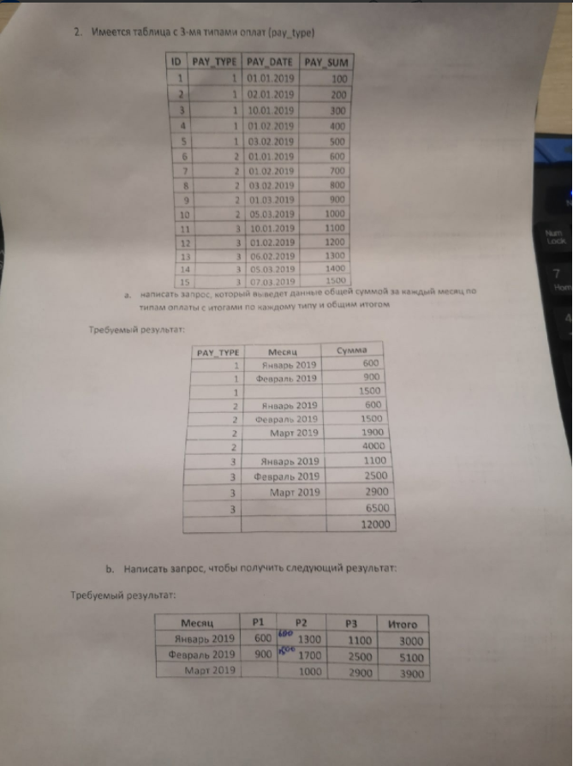

**Задание 1 – удаление дубликатов**

DELETE Table_1 WHERE id not in(

SELECT MAX(id) FROM Table_1

GROUP BY a,b)

**Задание 2.1**

SELECT

cast(pay_type as varchar) as pay_type,

format(pay_date, 'MM/yyyy') as 'Месяц'

,sum(pay_sum) as 'Сумма'

FROM Table_2

GROUP BY pay_type, format(pay_date, 'MM/yyyy')

UNION

SELECT

cast(pay_type as varchar) as pay_type,

'',

sum(pay_sum) as 'Сумма'

FROM Table_2

Group by pay_type

UNION

SELECT

'' as pay_type,

''as 'Месяц',

sum(pay_sum) as 'Сумма'

FROM Table_2

Order by pay_type, 'Сумма'

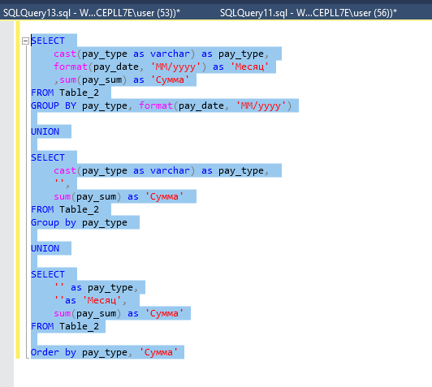

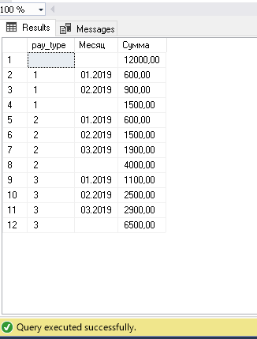

**Задание 2.2**

SELECT pay_date, [1] as 'P1',[2] as 'P2',[3] as 'P3',[4] as 'Итого'

FROM (SELECT

pay_type,

format(pay_date, 'MM/yyyy') as pay_date

,sum(pay_sum) as summa

FROM Table_2

GROUP BY pay_type, format(pay_date, 'MM/yyyy')

union

SELECT

4,

pay_date,

sum(summa) as summa

FROM (

SELECT

format(pay_date, 'MM/yyyy') as pay_date,

sum(pay_sum) as summa

FROM Table_2

Group by pay_date) as Tbl2

group by pay_date

) as Tbl

PIVOT ( sum(summa) for pay_type in ([1],[2],[3],[4])) as Test

